Whakarewarewa School
Information Booklet
2024

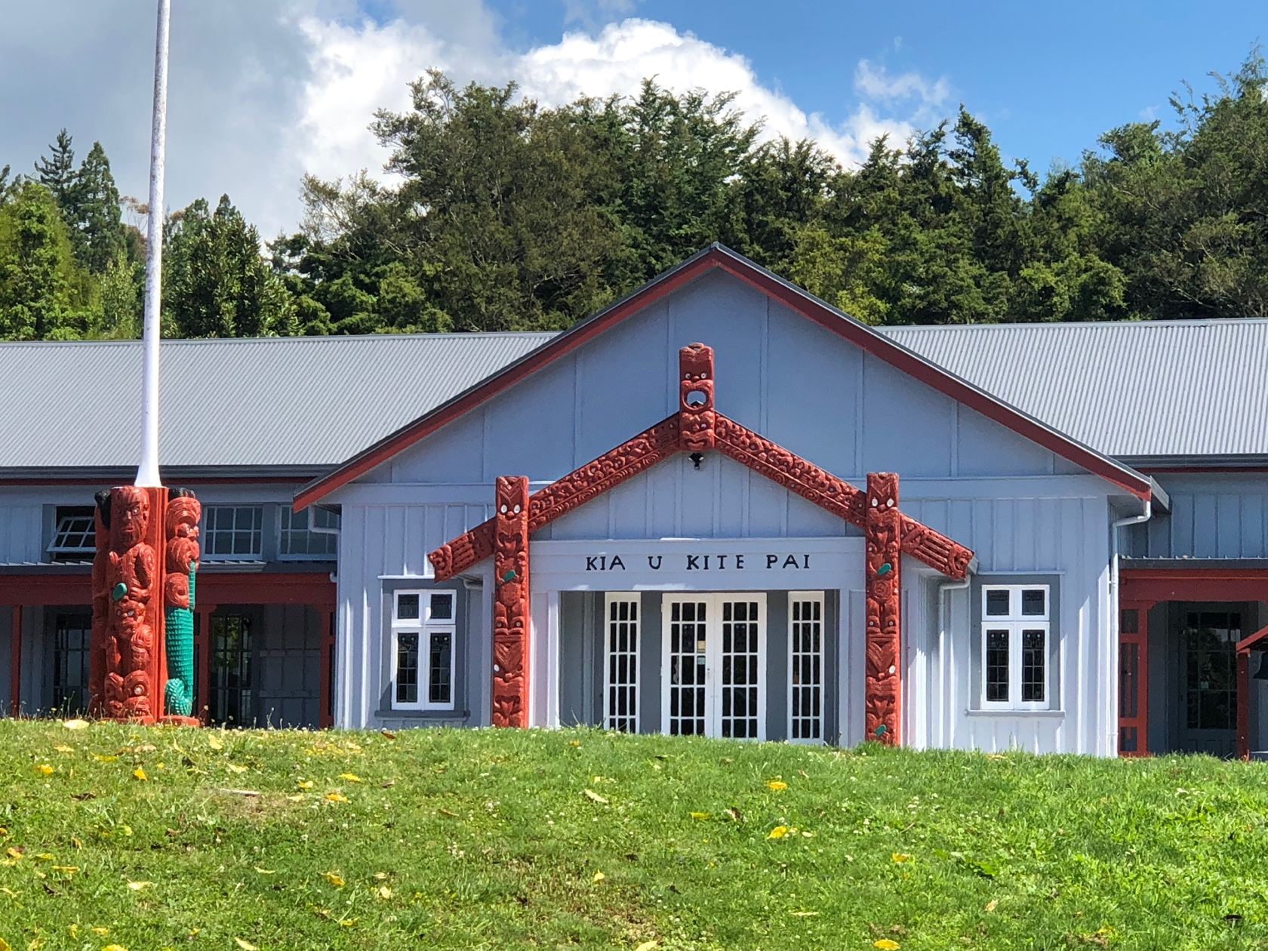

Table of Contents
SCHOOL STAFF 2023 3
ALLERGIES/MEDICATION 4
ASSEMBLIES 4
ATTENDANCE 4
BEHAVIOUR 4
COLLECTING CHILDREN DURING SCHOOL TIME 4
CARE OF PROPERTY 5
CARPARK 5
CELL PHONES 5
CHANGING ADDRESS/PHONE NUMBERS 5
A CIVIL EMERGENCY – Earthquake, fire, flood… 5
DENTAL/EAR/VISION/HEALTH NURSE/SOCIAL WORKER IN SCHOOLS 5
DATES FOR THE YEAR 5
ELECTRONIC EQUIPMENT INCLUDING CHROMEBOOKS 5
ENROLMENTS 5
EVACUATION DRILLS 6
FIRST AID 6
FOOTWEAR 6
FUNDRAISING 6
HEAD LICE 6
HEALTH AND SAFETY 6
IMMUNISATIONS 6
KAPA HAKA 6
KAI 7
LIBRARY 7
LOST PROPERTY 7
LUNCHES 7
MONEY 7
PARENT CONCERNS 7
POLICIES & PROCEDURES 7
PRECIOUS BELONGINGS/TOYS 7
COMMUNICATION WITH PARENTS 7
SCHOOL HALL HIREAGE 8
SCHOOL HOURS 8
SCHOOL PHOTOGRAPHS 8
MEETINGS 8
SICKBAY 8
SMOKEFREE 8
STATIONERY 8
SWIMMING 8
TRANSPORT 8
UNIFORMS 9
EDUCATION OUTSIDE THE CLASSROOM 9
FUNDRAISING 9
SPORTS & EOTC TRIPS 9

SCHOOL STAFF 2024

Jackie Meha | Principal
Yvonne Edwards | Deputy Principal/Teacher | Y5 & Y6
Lisa Reweti | Rumaki Teacher | Y0-2
Raiha Ratapu | Rumaki Teacher | Y3-4
Anna May | Rumaki Teacher | Y5-8
Angelique Curtis | Teacher | Y0-2
Rea Martin | Learning Support Coordinator
Iti Pou | Teacher Aide | Driver
Elaine Koia | Teacher Aide
Pauline Grant | Teacher Aide
Katerama Pou | Kaiarahi I te Reo
Rexina Morgan | Teacher Aide | Driver
Aroha Rapana | Property Manager | Caretaker
Pam Takiwa | Office Manager/Board Secretary | Support Staff
Board of Trustees
Michele Hawe | Board Member | Elected 2022
Jaylene Tamati | Board Member | Elected 2022
Renaata McGarvey | Board Member | Elected 2022
Warena Morgan | Board Member | Elected 2022
Angelia-Jolie Baker | Board Member | Elected 2022
Yvonne Edwards | Staff Rep | Elected 2023

GENERAL INFORMATION

ALLERGIES/MEDICATION
If your child has an allergy or requires medication it is necessary to inform the school about this.

All medication must be brought to the school by the parent with full instructions. This will be administered by staff.

ASSEMBLIES
We are currently in COVID times and therefore we are not having assemblies. We are regularly reviewing this and will notify whanau when assemblies will restart.

ATTENDANCE
  - Students who are late in the morning must report to the office before going to class.

  - Parents – Please ring the school 07 348 3865 and leave a message when your child is not at school.

  - Text the teacher

  - Send a note or message explaining absence when your child returns to school Acceptable reasons for being absent from school are sickness and tangi. ATTENDANCE = ACHIEVEMENT

BEHAVIOUR
All students and staff are expected to demonstrate our school values of Manaakitanga, Aroha, Mana, Tika me te pono at all times.

Our school strives to work restoratively in all incidents. Parents will be contacted for incidents of serious concern

COLLECTING CHILDREN DURING SCHOOL TIME
Learning takes priority. The school day begins at 9am and concludes at 3pm. Parents collecting children between these hours are required to:

- Make contact with Principal/teacher/office beforehand if circumstances are organised e.g. Specialist appointment
- Collect tamariki from the school office
- Sign in at the school office and sign out your child. (Children will be released to primary caregiver or one nominated by the caregiver

CARE OF PROPERTY
Any school property taken home by children should be treated with respect and returned to school in the same condition they go home in.

Parents may be asked to pay for loss or damage to school property. This also refers to damage of property at school.

CARPARK
Parents and visitors are asked to park at the sealed parking lot by the school office. There is also a lower car park to the left of the entry bridge and the barked area in front of the school house and not on the grassed oval.

CELL PHONES
In the interest of security – students are not permitted to bring cell phones to school. Please phone the school office before and after school to talk to classroom teachers.

CHANGING ADDRESS/PHONE NUMBERS
Please remember to notify the school if you move to a new address or the telephone numbers for yourself or your listed emergency contacts have changed

A CIVIL EMERGENCY – Earthquake, fire, flood…
In a civil emergency, children will be held at school until collected by their parents/caregivers or the emergency contact person recorded in the school records. Children will not be released to any other person.
Please inform the student's teacher when collecting your child/children in this type of emergency.

DENTAL/EAR/VISION/HEALTH NURSE/SOCIAL WORKER IN SCHOOLS
These services are available for all students. Please contact the school office.

DATES FOR THE YEAR
Term 1 – 31 January to 06 April
Term 2 – 24 April to 30 June
Term 3 – 17 July to 22 September
Term 4 – 9 October to 14th December

ELECTRONIC EQUIPMENT INCLUDING CHROMEBOOKS
Our teachers have locked up cupboards in each classroom if students require their electronic equipment to be locked up during school hours. Personal devices are the responsibility of the owner. Please ensure your child secures their device when they are not using it

ENROLMENTS
When enrolling five-year olds for the first time – please bring:

- Child’s birth certificate
- Immunisation certificate signed by your doctor or nurse – this is required by law.
- Any other documentation that might help us to understand your child
- Meet and interview with the Principal.

EVACUATION DRILLS
These will be held each term. Our students will become familiar with the evacuation procedures. Long bell = earthquake. Recording/speaker = fire.

FIRST AID
Basic first aid will be administered as required. Accidents are recorded in the accident register book and parents notified.

FOOTWEAR
All students must wear black closed in footwear or black roman sandals.

FUNDRAISING
Every Friday we will have a mufti day for a gold coin donation that will be used to subsidise school trips.

HEAD LICE
Throughout the year there are times when head lice can be in your child’s hair. Would you check your child's hair regularly and advise the school if an infestation occurs?

HEALTH AND SAFETY
Every effort is made to contact parents in the case of an injury to children while they are at school. In an emergency, the child’s doctor will be contacted, or the child is taken to hospital.

A Korowai Aroha Nurse visits the school regularly and checks children for health issues not requiring immediate medical attention

IMMUNISATIONS
The Lakes District Health Board Public Nursing Service is responsible for delivering the immunisation programmes in Rotorua. Concerned children and their parents will be notified when these take place. Before those immunisations are given consent, forms will need to be returned to school.

KAPA HAKA
Our children participate annually in the Rotorua Primary Schools Festival held in Term
4. This has been a successful event where all students thoroughly enjoy themselves.

KAI
We have three programmes running in the school:

- Weetbix & milk is supplied by Sanitarium & Fonterra
- Yoghurt, fruit pottles and scroggan from Kids Can.
- Fresh fruit – Fruit in Schools

LIBRARY
From time to time we have the services of the Rotorua District Council Mobile Library.

LOST PROPERTY
To minimise the items in our Lost Property – Please name all uniform items. All, found items are returned if named otherwise they will be kept in the school office.

LUNCHES
Whakarewarewa School provides free lunches for all students sponsored through the Government's free lunches for student’s initiative.

MONEY
All money to be received and receipted in the school office.

PARENT CONCERNS
Please contact your child’s teacher in the first instance. Usually all matters can be rectified when this communication takes place. The Deputy Principal or Principal will only be involved in matters of Serious Concern.

POLICIES & PROCEDURES
All policies and procedures are kept in a folder in the office and are available for you to read while you are at the school

PRECIOUS BELONGINGS/TOYS
It is preferred that the children did not bring their precious games and belongings to school. Please keep them at home as damage or loss is very distressing. The school will not take responsibility for this.

COMMUNICATION WITH PARENTS
Our staff provide many forms of communications with parents/whanau.
- School newsletters each fortnight
- Class notices to parents
- Communication books each term
- Skool Loop
- School hui during the year
- School web page
- Copies of the Charter are available on request
- Text/Phone calls

SCHOOL HALL HIREAGE
We are not hiring our hall at this time.

SCHOOL HOURS
School will be open from 9am to 2.30pm daily.
The school office will be open from 8.30am – 3.00pm daily.

SCHOOL PHOTOGRAPHS
These are taken once a year.

MEETINGS
It is important that parents make appointments though the office if they wish to visit the Principal, their child’s teacher, or take a child out of class.

SICKBAY
If your child becomes ill or has an accident the Office Manager will make, contact with you to collect your child.

SMOKEFREE
Whakarewarewa School is a smoke free zone. No smoking within the school grounds at any time.

SWIMMING
All students are required to wear togs in our school pool. Casual clothing is not acceptable. Please support your child by providing proper swimming gear, a towel and a plastic bag. Swimming lessons at school ARE COMPULSORY.

TRANSPORT
The school has three vans collecting students from around Rotorua city.
- $5/week per child = $50 per term = $200 per year.
- $10/week for 3+ children from the same family/home.
- $100 per term = $400 per year.

Payment of the transport cost secures a seat to and from school regardless of whether children ride on both runs.
Parents MUST contact the school by phone or note for any of the following: When children do not require pickup because they are sick
When children do not require pick up at all for known dates

If your child/children catch the van to school, you are required to contact Whaea Yvonne so that she can inform the drivers.

UNIFORMS
These are available from our school office. Please contact our Office Manager on 07 3483865 if you have any queries.

Extra - Curricular Activities

EDUCATION OUTSIDE THE CLASSROOM
All children will be involved in outdoor education/trips throughout the year. These trips may come at an extra cost. We encourage all students to participate.

Each event will have different expectations and will follow the school's policies and procedures.

FUNDRAISING
Assistance in this area is always appreciated. Everyone will be informed of fundraising events through newsletters.

SPORTS & EOTC TRIPS
Under the current health and safety rules we are unable to ask for parent support.

